|  |
| --- |
| CSULB ACM |
| Augmented eBay |
| Empower your eBay listing with rich multimedia, files and intertwine with social media for less |
|  |
| Karan Bhandari, Jarrod Dickerson, Vipul Chopra, Varun Chopra ,Saied |
| **10/16/2011** |

|  |
| --- |
| - |

Contents

Charter 1



# Modified Charter

• Project Manager – Karan Bhandari

Project Definition – This web/mobile application will enable eBay sellers to list items with rich text pictures, videos and files for free.

• Project Scope – Two applications

o Augmented eBay

o Augmented eBay Pro: access to device I/O and file manager (marked by *)

It empowers the seller to upload eBay listings with the aid of following features.

* Rich text description
* Ability to append more than 1 image (upto 20 or more*)for free by the following means
  + Image Url
  + Laptop / Phone /Tablet Gallery
  + Camera *
* Ability to append multiple videos
  + Upload *
  + Youtube URL
  + Laptop / Phone /Tablet Gallery
* Ability to upload files
  + Windows Skydive URL
  + Upload *
* Ability to select background themes and layout.
* Ability to tweet as soon as item is listed
* Gain visibility on Youtube

• Project Goals – Stepping stone towards Innovation Challenge and eventually own company.

• Project Dependencies – Sencha, ASP.NET, PhoneGap, C#.NET 4.0 and server (kurtzace.com)

• Project Team – Karan Bhandari, Varun Chopra, Vipul Chopra , Saied Farivar and Jarrod Dickerson.

• Project Stakeholders –

* One mentor chosen by the board of College of Engineering Innovation challenge committee.
* Ebay

• Project Phases –

o Acceptance into eBay developer’s program.

o Construction of Application.

o Scrutiny by eBay

o Deploy to mobile marketplace

• Project Timeline – By the end of the semester

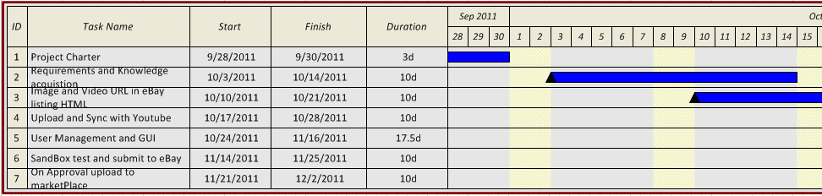

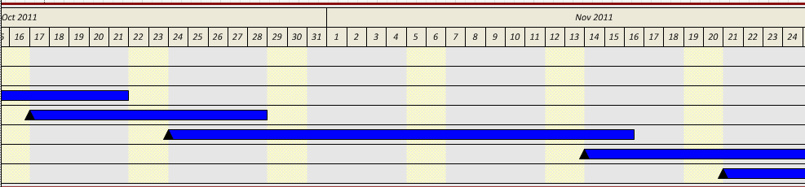

• Project Challenges – Once the application is constructed, it has to pass the eBay screening program.

• Project Finances – None.

• Project Estimated Completion Time – ~140hours.

• Project Status – We have server space in kurtzace.com, we are accepted into eBay developer’s program, commenced application construction.

• Project Contact(s) – Karan Bhandari, +1 302 438 2953.

Karan.bhandari@student.csulb.edu